Compute for any workload

Instances, containers, and serverless computing

Millions of organizations run diverse workloads on the AWS compute platform. Recognized as a [Magic Quadrant Leader](https://aws.amazon.com/resources/analyst-reports/gartner-mq-cips-2021/?trk=ta_a134p000007CEQqAAO&trkCampaign=GLBL-Download_GC_Report-FY21-AR-100-Gartner-CIPS-MQ&sc_channel=ta&sc_campaign=WebPlacementsCIPSMQ21&sc_outcome=Global_Marketing_Campaigns&sc_geo=mult&sc_country=mult) for Cloud Infrastructure and Platform Services for the 11th straight year, AWS is helping organizations like Lyft, Netflix, Coca-Cola, and Moderna lower infrastructure costs and accelerate innovation on the world's most reliable, secure, and capable cloud.

Right compute for your workloads

AWS offers the broadest and deepest functionality for compute. [Amazon Elastic Cloud Compute (EC2)](https://aws.amazon.com/ec2/) offers granular control for managing your infrastructure with the choice of processors, storage, and networking. AWS container services offer the best choice and flexibility of services to run your containers. [AWS Lambda](https://aws.amazon.com/lambda/) enables you to run code in response to events from more than 150 natively integrated AWS and software as a service (SaaS) sources.

From idea to market, faster

AWS provides multiple ways to build, deploy, and get to market quickly on the latest technology. The [AWS Nitro System](https://aws.amazon.com/ec2/nitro/), exclusive to AWS, enables us to rapidly innovate, which means you’re always building on the latest technologies. Get started quickly with [Amazon Lightsail](https://aws.amazon.com/lightsail/), a virtual private server for a low, predictable price, and serverless computing with AWS Lambda.

Security, built in

AWS offers significantly more [security, compliance, and governance services, and key features](https://aws.amazon.com/products/security/?nc2=h_ql_prod_se) than the next largest cloud provider. With the AWS Nitro System, security is built in at the chip level to continuously monitor, protect, and verify the instance hardware and minimize potential attack surfaces. AWS also supports more security standards and certifications than any other cloud provider, including PCI-DSS, HIPAA/HITECH, FedRAMP, GDPR, FIPS 140-2, and NIST800-171.

Flexibility to optimize costs

With AWS compute you pay only for the instance or resource you need, for as long as you use it, without requiring long-term contracts or complex licensing. We offer automated recommendations to help you improve price performance as well as tools and innovative pricing models to further optimize costs. With [EC2 Spot Instances](https://aws.amazon.com/ec2/spot/) you can save up to 90 percent over on-demand pricing for instances, or with Savings Plans you can save up to 72 percent across instances, containers, and serverless on a single bill.

Compute where you need it

AWS is the only cloud provider that distributes a consistent set of services from the cloud, to your data center, to the edge. [AWS Outposts](https://aws.amazon.com/outposts/) extends AWS infrastructure, services, APIs, and tools to any facility. Amazon Elastic Container Service (ECS) Anywhere and Amazon Elastic Kubernetes Service (EKS) Anywhere let you run containers on premises using the same APIs and cluster management that you use in the cloud. [AWS Wavelength](https://aws.amazon.com/wavelength/) delivers ultra-low latency for 5G-enabled applications through telecommunications companies around the world.

500+

instances for virtually every business need

80%

of all containerized applications running in the cloud run on AWS\*

84%

of all Kubernetes workloads in the cloud run on AWS\*

84

Availability Zones that are multiple, physically separated, and isolated

26

AWS Regions with lower latency, high throughput, and high redundancy

\* <https://nucleusresearch.com/research/single/guidebook-containers-and-kubernetes-on-aws/>

## **Gartner Names AWS a 2021 Magic Quadrant Leader**

Gartner has recognized AWS as a [Magic Quadrant Leader for Cloud Infrastructure and Platform Services](https://pages.awscloud.com/GLOBAL-multi-DL-gartner-mq-cips-2020-learn.html) for the 11th straight year. Millions of customers choose AWS to host their cloud-based infrastructure and realize increased performance, security, reliability, and scale. AWS placed highest in both axes of measurement—Ability to Execute and Completeness of Vision—among the top seven vendors named in the report.

You can read the full Gartner report [here](https://pages.awscloud.com/GLOBAL-multi-DL-gartner-mq-cips-2020-learn.html).

[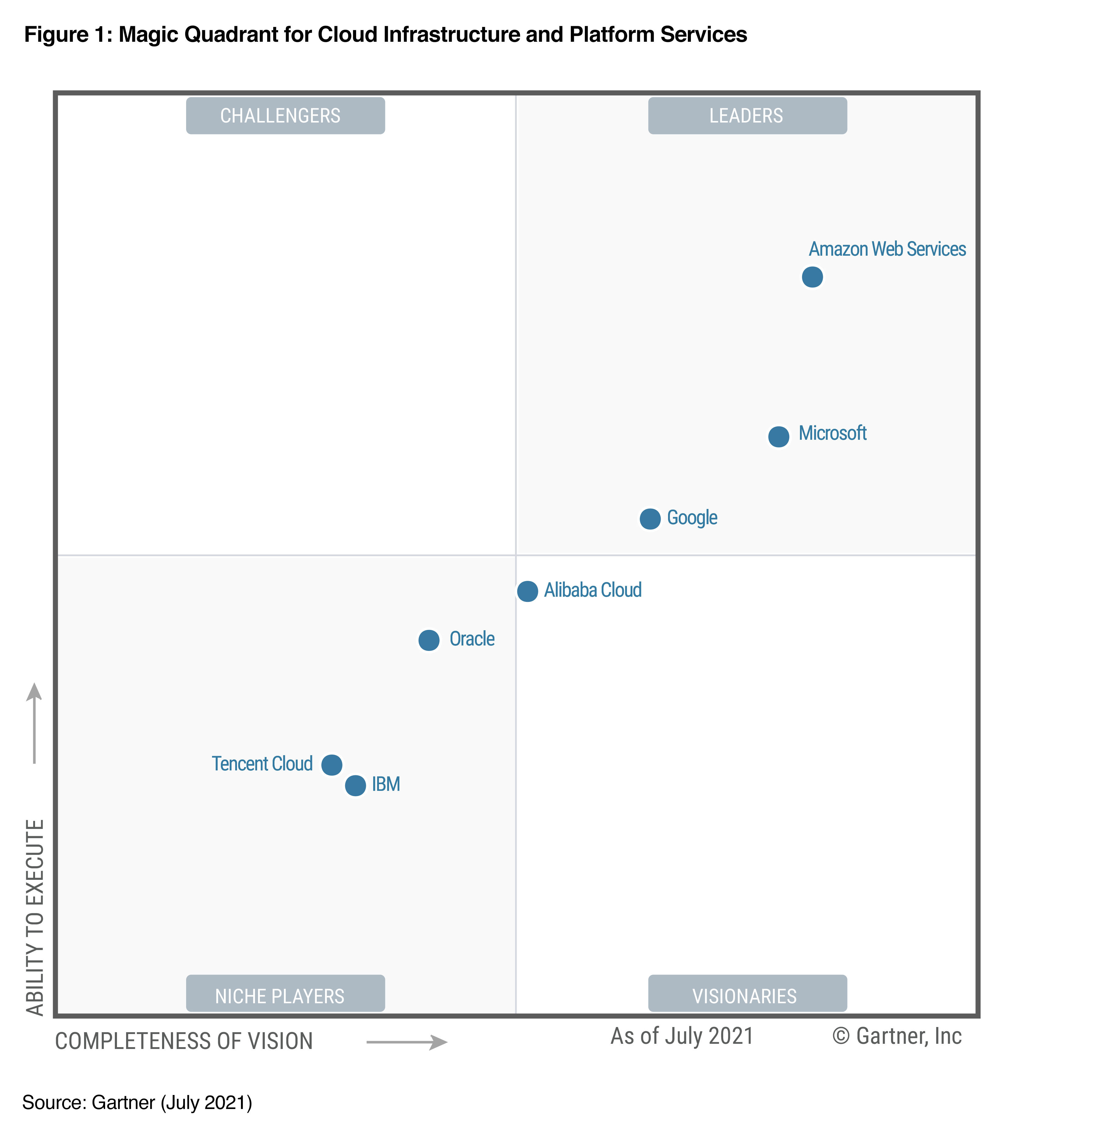](https://aws.amazon.com/resources/analyst-reports/gartner-mq-cips-2021/?trk=ta_a134p000007CEQqAAO&trkCampaign=GLBL-Download_GC_Report-FY21-AR-100-Gartner-CIPS-MQ&sc_channel=ta&sc_campaign=WebPlacementsCIPSMQ21&sc_outcome=Global_Marketing_Campaigns&sc_geo=mult&sc_country=mult)

## **AWS compute services**

Category

Service description

AWS service

Instances (virtual machines)

Secure and resizable compute capacity (virtual servers) in the cloud

[Amazon Elastic Compute Cloud (EC2)](https://aws.amazon.com/ec2/?c=cp&sec=srv)

Run fault-tolerant workloads for up to 90% off

[Amazon EC2 Spot](https://aws.amazon.com/ec2/spot/?c=cp&sec=srv)

Automatically add or remove compute capacity to meet changes in demand

[Amazon EC2 Autoscaling](https://aws.amazon.com/ec2/autoscaling/?c=cp&sec=srv)

Easy-to-use cloud platform that offers you everything you need to build an application or website

[Amazon Lightsail](https://aws.amazon.com/lightsail/?c=cp&sec=srv)

Fully managed batch processing at any scale

AWS-Batch_Icon_32_Squid

[AWS Batch](https://aws.amazon.com/batch/?c=cp&sec=srv)

Containers

Highly secure, reliable, and scalable way to run containers

[Amazon Elastic Container Service (ECS)](https://aws.amazon.com/ecs/?c=cp&sec=srv)

Run containers on customer-managed infrastructure

[Amazon ECS Anywhere](https://aws.amazon.com/ecs/anywhere/?c=cn&sec=srv)

Easily store, manage, and deploy container images

[Amazon Elastic Container Registry (ECR)](https://aws.amazon.com/ecr/?c=cp&sec=srv)

Fully managed Kubernetes service

[Amazon Elastic Kubernetes Service (EKS)](https://aws.amazon.com/eks/)

Create and operate Kubernetes clusters on your own infrastructure

[Amazon EKS Anywhere](https://aws.amazon.com/eks/eks-anywhere/)

Serverless compute for containers

[AWS Fargate](https://aws.amazon.com/fargate/?c=cp&sec=srv)

Build and run containerized applications on a fully managed service

[AWS App Runner](https://aws.amazon.com/apprunner/?c=cp&sec=srv)

Serverless

Run code without thinking about servers. Pay only for the compute time you consume

[AWS Lambda](https://aws.amazon.com/lambda/?c=cp&sec=srv)

Edge and hybrid

Run AWS infrastructure and services on premises for a truly consistent hybrid experience

[AWS Outposts](https://aws.amazon.com/outpost/?c=cp&sec=srv)

Collect and process data in rugged or disconnected edge environments

[AWS Snow Family](https://aws.amazon.com/snow/?c=cp&sec=srv)

Deliver ultra-low latency application for 5G devices

Wavelength

[AWS Wavelength](https://aws.amazon.com/wavelength/?c=cp&sec=srv)

Preferred service for all vSphere workloads to rapidly extend and migrate to the cloud

[VMware Cloud on AWS](https://aws.amazon.com/vmware/?c=cp&sec=srv)

Run latency sensitive applications closer to end-users

[AWS Local Zones](https://aws.amazon.com/about-aws/global-infrastructure/localzones/?c=cp&sec=srv)

Cost and capacity management

Flexible pricing model that provides savings of up to 72% on AWS compute usage

[AWS Savings Plan](https://aws.amazon.com/savingsplans/?c=cp&sec=srv)

Recommends optimal AWS compute resources for your workloads to reduce costs and improve performance

AWS-Compute-Optimizer_Icon_32_Squid

[AWS Compute Optimizer](https://aws.amazon.com/compute-optimizer/?c=cp&sec=srv)

Easy-to-use service for deploying and scaling web applications and services

AWS-Elastic-Beanstalk_Icon_32_Squid

[AWS Elastic Beanstalk](https://aws.amazon.com/elasticbeanstalk/?c=cp&sec=srv)

Build and maintain secure Linux or Windows Server images

EC2-Image-Builder_Icon_32_Squid

[EC2 Image Builder](https://aws.amazon.com/image-builder/?c=cp&sec=srv)

Automatically distribute incoming application traffic across multiple targets

Elastic-Load-Balancing_Icon_32_Squid

[Elastic Load Balancing (ELB)](https://aws.amazon.com/elasticloadbalancing/?c=cp&sec=srv)

## **The AWS Nitro System**

Regardless if you are migrating apps from on premises or building them natively in the cloud, you can benefit from Amazon EC2 instances built on the AWS Nitro System. The [AWS Nitro System](https://aws.amazon.com/ec2/nitro/) enables AWS to innovate faster, further reducing cost for our customers, and deliver added benefits like increased security and new instance types. AWS has completely re-imagined our virtualization infrastructure. Traditionally, hypervisors protect the physical hardware and BIOS, virtualize the CPU, storage, and networking, and provide a rich set of management capabilities. With the Nitro System, we are able to break apart those functions, offload them to dedicated hardware and software, and reduce our costs by delivering all of the resources of a server to customers.

The Nitro System is comprised of three main parts: The Nitro Cards are a family of cards that offloads and accelerates I/O for functions including Amazon Virtual Private Cloud (VPC), Amazon Elastic Block Store (EBS), and Amazon EC2 instance storage, ultimately increasing overall system performance. The Nitro Security Chip enables the most secure cloud platform with a minimized attack surface as virtualization and security functions are offloaded to dedicated hardware and software. Additionally, a locked-down security model prohibits all administrative access, including those of Amazon employees, eliminating the possibility of human error and tampering. The Nitro Hypervisor is a lightweight hypervisor that manages memory and CPU allocation and delivers performance that is indistinguishable from bare metal.

## **Customers**

* 

* 

* 

* 

* 

* 

Expedia Group is all in on AWS, with plans to migrate 80 percent of its mission-critical apps from its on-premises data centers to the cloud in the next two to three years. By using AWS, Expedia Group has become more resilient. Expedia Group’s developers have been able to innovate faster while saving the company millions of dollars.

[Read the customer story »](https://aws.amazon.com/solutions/case-studies/expedia/)

## **Easy to migrate and build apps**

AWS provides multiple ways to get you started quickly and easily. Amazon Lightsail offers a simple cloud platform at a low, predictable price. AWS Amplify is a set of tools and services to help front-end web and mobile developers build scalable full stack applications. The AWS Marketplace is a digital catalog with thousands of software listings from independent software vendors that make it easy to find, test, buy, and deploy software that runs on AWS. There are migration tools as well as AWS Managed Services, AWS Professional Services, AWS Training and Certification, and AWS Support to assist along the way. We have the largest and most vibrant partner community including system integrators, ISVs, and SaaS partners.